PROJECT REPORT

**on**

**TRAVEL & TOUR WEBSITE**

## Submitted by

**Mohini Das Roll No: 201500404**

**Saraswati Kumari Roll No: 191500722**

**Sakshi Agrawal Roll No: 201500606**



# Department of Computer Engineering & Applications

**Institute of Engineering & Technology**

## GLA University, Mathura- 281406, INDIA

 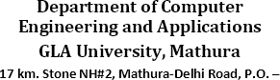



## Declaration

I hereby declare that the work which is being presented in the Project Report **“Travel & Tour Website”,** in partial fulfillment of the requirements for Project is an authentic record of my own work carried under the supervision of **Mr. Bhanu Kapoor, Assistant Professor, GLA University, Mathura**.

Sign

Name of Candidate: Mohini Das University Roll No.: **201500404**

Sign

Name of Candidate: Saraswati Kumari University Roll No.: **191500722**

Sign

Name of Candidate: **Sakshi Agrawal**

University Roll No.: **201500606**

**Certificate**

This is to certify that the above statements made by the candidate are correct to the best of our team members’ knowledge and belief.

**Project Supervisor Mr. Bhanu Kapoor**

Date:

**Table of Contents**

1. Introduction
2. Code
3. Objective
4. Languages Used
5. Conclusion
6. Reference

## Introduction

* + It's an online website where we provide you to Book online ticket for Travel any Place in India.
  + Through the web Browser Wonder lust can easily book

ticket for Tour.

* + If you want to become our permanent member you can

sign in.

## Objective

This website plays an important role in providing Adventurous life. Without any issue You can easily visit our website. In this website you need to subscribe, if you want to become a permanent member. I hope this is helpful for you all.

Code:

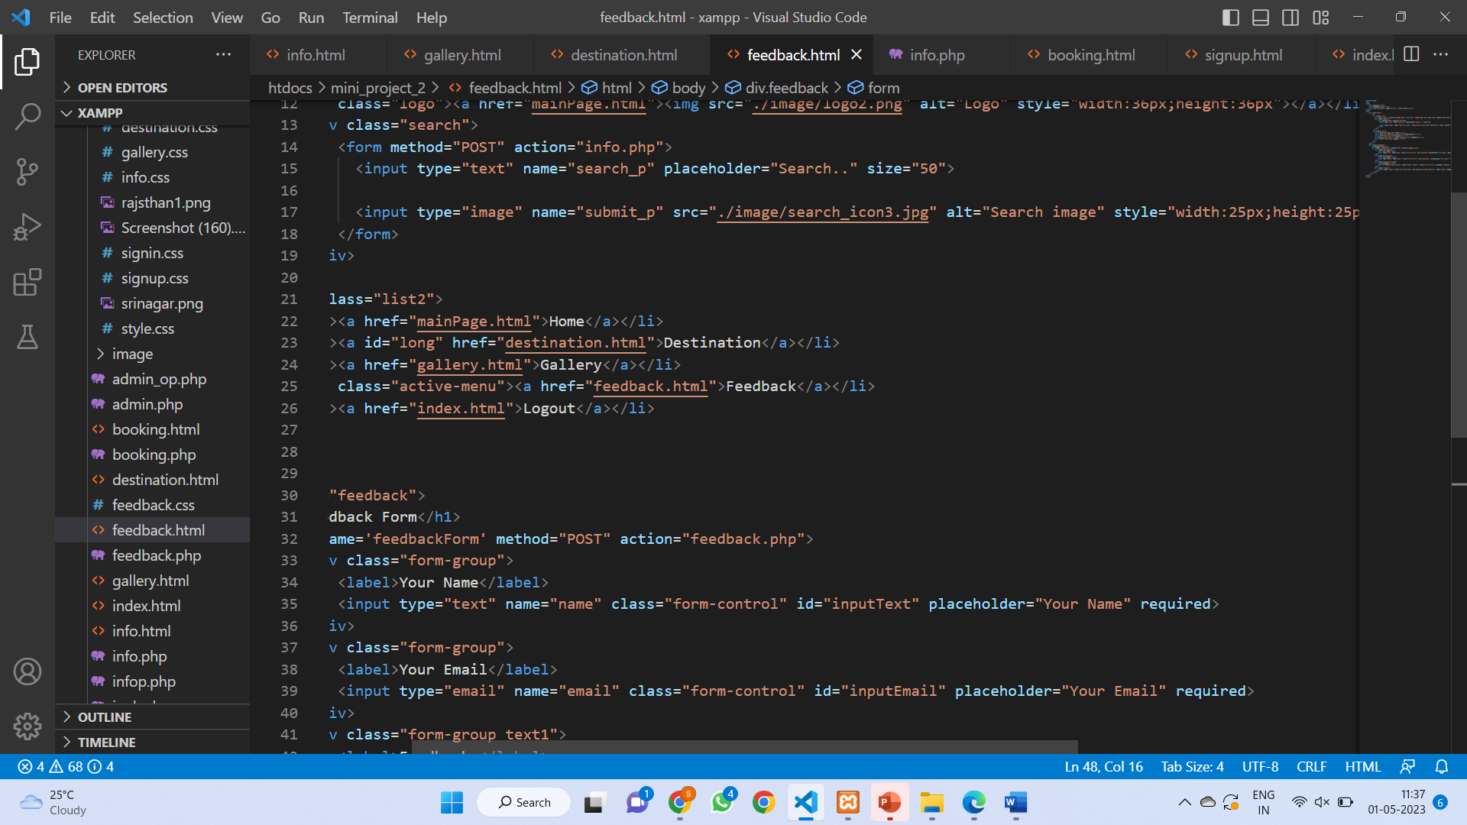

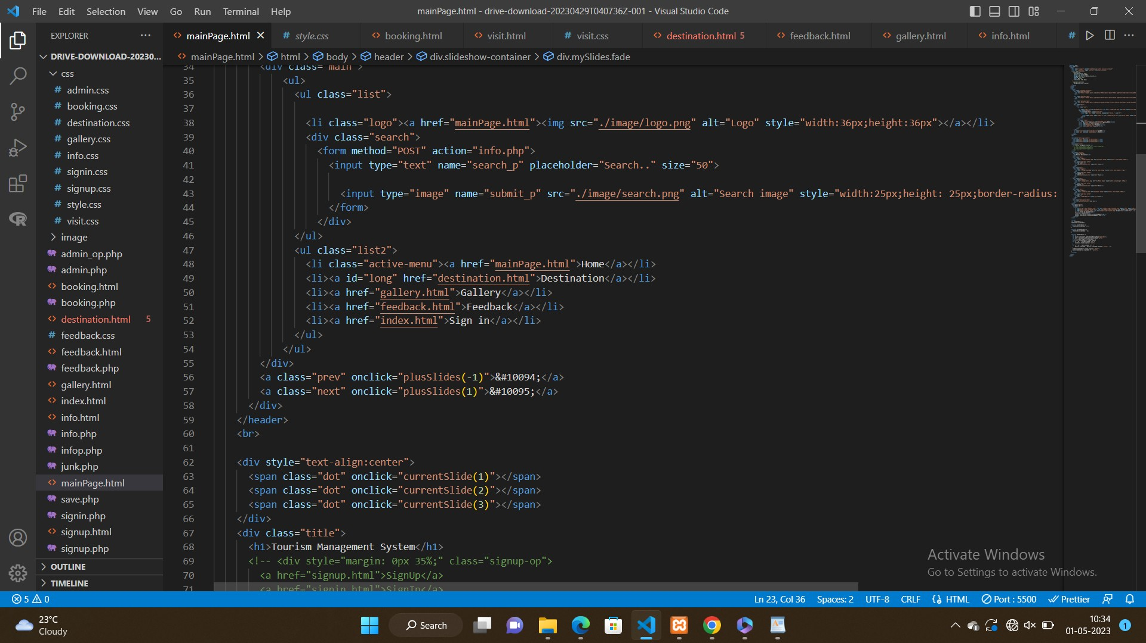

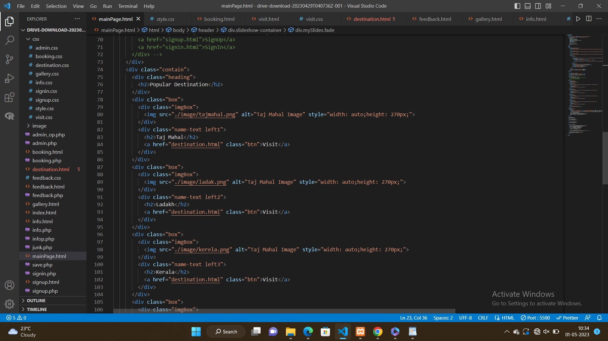

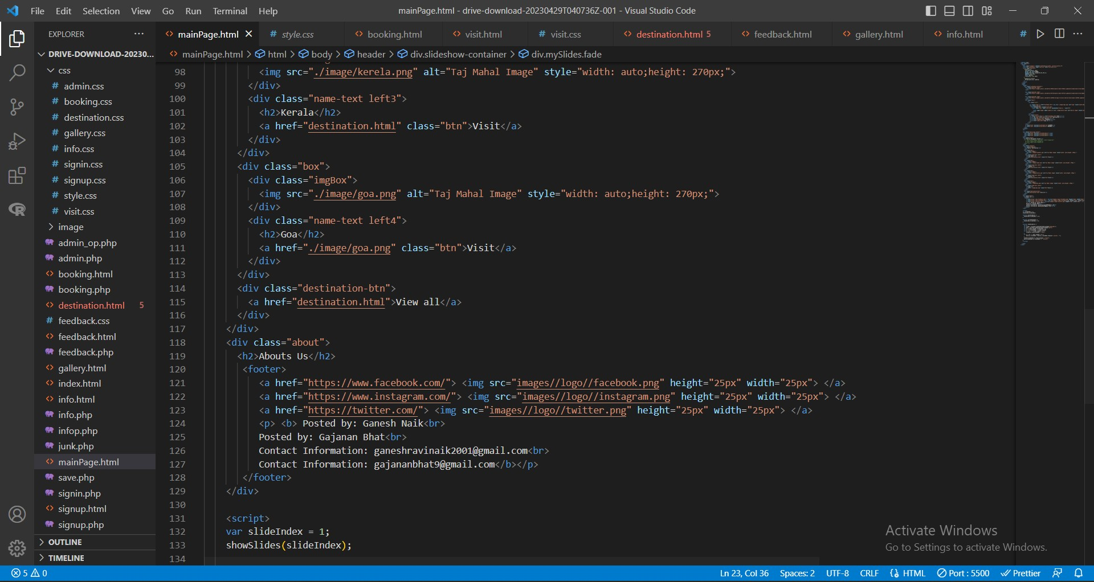

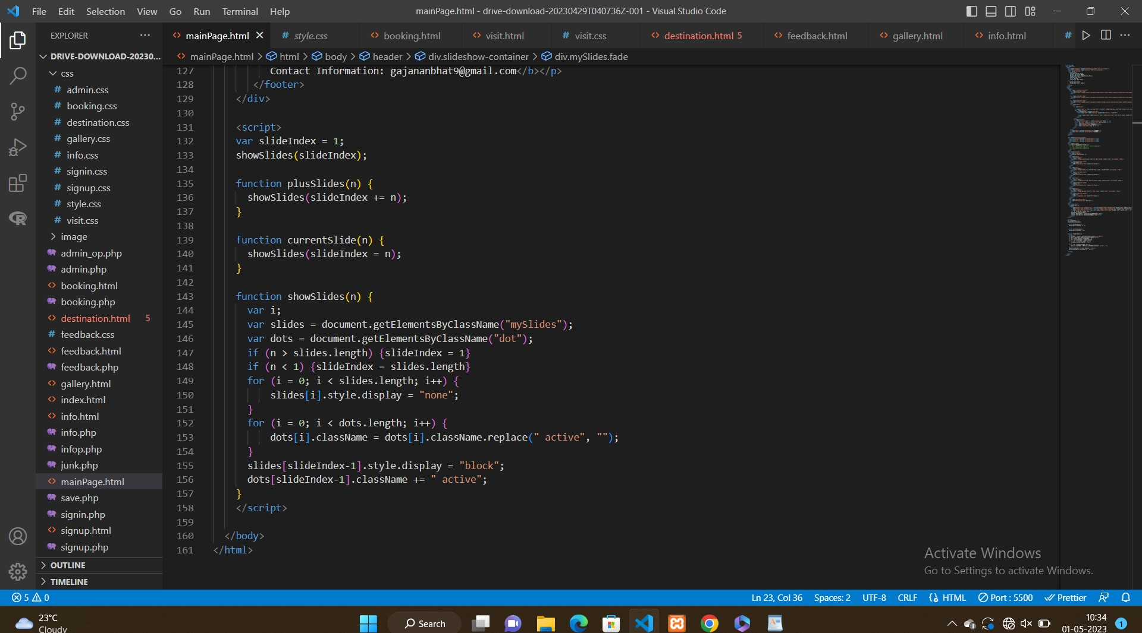

## Objective

This website plays an important role in providing Adventurous life. Without any issue You can easily visit our website. In this website you need to subscribe, if you want to become a permanent member. I hope this is helpful for you all.

## LANGUAGES USED

**HTML**

Html stands for "Hyper Text Markup Language" It was developed by time Berners-Lee in 1993

5.3 is the latest version of HTML

## CSS

CSS stand for "Cascading Style Sheet

It was developed by Hakon Wium Lie in 1996 3 is the latest version of CSS.

**JS**

JS stands for JavaScript

It was developed by Brendan Eich in 1995 ES2015 is the latest version of JavaScript

### PHP-Scripting language

PHP stands for Hypertext Preprocessor

It was developed by Rasmus Lerdorf in 1994

**php8.2** is the latest version of php

Conclusion

"Thank you for considering our travel and tour packages. We are confident that we can provide you with an unforgettable experience that will create memories to last a lifetime. Our packages are carefully designed to cater to a wide range of interests, budgets and preferences, from adventurous backpacking to luxurious getaway.

# Reference

**.**"Global Tourism Industry Statistics & Facts." Statista. Accessed April 26, 2023. [https://www.statista.com/topics/962/global-tourism/.](https://www.statista.com/topics/962/global-tourism/)

**.**"Tourism Trends: The Latest and Greatest." Skift Research. Accessed April 26, 2023. [https://research.skift.com/report/tourism-trends-the-latest-and-greatest/.](https://research.skift.com/report/tourism-trends-the-latest-and-greatest/)